# WEEK 4: DIVIDE AND CONQUER

**PROGRAM 1:**

**AIM:** Given an array of 1s and 0s this has all 1s ﬁrst followed by all 0s. Aim is to ﬁnd the number of 0s. Write a program using Divide and Conquer to Count the number of zeroes in the given array.

**ALGORITHM:**

Step 1: Input the size of the array and the elements.

Step 2: Define the recursive divide function to find the first occurrence of 1. Step 3: Call the divide function and compute the result.

Step 4: Output the result.

### PROGRAM:

#include <stdio.h> int divide(int [],int,int);

int divide(int a[],int left,int right)

{

int mid=0; mid=left+(right-left)/2; if (a[0]==0)

return 0;

else if (a[right-1]==1) return right;

if ((a[mid]==0) && (a[mid-1]==0)) return divide(a,0,mid);

else if (a[mid]==0) return mid;

else

return divide(a,mid+1,right);

}

int main()

{

int n; scanf("%d",&n); int arr[n];

for (int i=0;i<n;i++)

{

scanf("%d",&arr[i]);

}

int zero=divide(arr,0,n); printf("%d",n-zero);

}

### OUTPUT:

**RESULT:** Thus the program is executed successfully.

### OUTPUT:

**RESULT:** Thus the program is executed successfully.

### PROGRAM 2:

**AIM:** Given an array nums of size n, return *the majority element*.

The majority element is the element that appears more than ⌊n / 2⌋ times. You may assume that the majority element always exists in the array.

### ALGORITHM:

Step 1: Input the size of the array and its elements.

Step 2: Define the recursive function Count to count occurrences of a specific element (key). Step 3: Find the majority element and check if its count exceeds half the array size.

Step 4: Handle edge cases where k is not the majority element. Step 5: Display the output

### PROGRAM:

#include<stdio.h>

int divide(int arr[],int low,int high)

{

if(arr[high]==1)

{

return 0;

}

if(arr[low]==0)

{

return high-low+1;

}

int mid=(low+high)/2;

int left=divide(arr,low,mid);

int right=divide(arr,mid+1,high);

return left+right;

}

int main()

{

int size;

scanf("%d",&size);

int arr[size];

for(int i=0;i<size;i++)

{

scanf("%d",&arr[i]);

}

int count=divide(arr,0,size-1);

printf("%d\n",count);

}

### OUTPUT:

**RESULT:** Thus the program is executed successfully.

**PROGRAM 3:**

**AIM:** Given a sorted array and a value x, the ﬂoor of x is the largest element in array smaller than or equal to x. Write divide and conquer algorithm to ﬁnd ﬂoor of x.

**ALGORITHM:**

Step 1: Input the size of the array and its elements.

Step 2: Define the search function to find the largest element smaller than or equal to x. Step 3: Call the search function and get the result.

Step 4: Output the result.

### PROGRAM:

#include<stdio.h>

int search(int arr[], int n, int x)

{

if (x>=arr[n-1]) return n-1;

if (x<arr[0]) return -1;

for (int i=1;i<n;i++) if (arr[i]>x)

return arr[i-1];

return -1;

}

int main()

{

int n; scanf("%d",&n); int a[n];

for (int i=0;i<n;i++)

{

scanf("%d",&a[i]);

}

int x; scanf("%d",&x);

int res=search(a, n, x); if (res!=-1)

printf("%d",res);

}

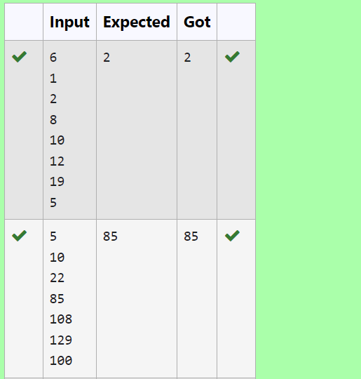**OUTPUT:**

**RESULT:** Thus the program is executed successfully.

### PROGRAM 4:

**AIM:** Given a sorted array of integers say arr[] and a number x. Write a recursive program using divide and conquer strategy to check if there exist two elements in the array whose sum = x. If there exist such two elements then return the numbers, otherwise print as “No”.

Note: Write a Divide and Conquer Solution

### ALGORITHM:

Step 1: Input the size of the array and its elements.

Step 2: Define the sum function to find two elements whose sum equals x. Step 3: Call the sum function to find the pair.

Step 4: Output the result.

### PROGRAM:

#include<stdio.h>

void merge(int arr[], int left, int mid, int right) {

int i, j, k;

int n1 = mid - left + 1;

int n2 = right - mid;

int leftArr[n1], rightArr[n2];

for (i = 0; i < n1; i++)

leftArr[i] = arr[left + i];

for (j = 0; j < n2; j++)

rightArr[j] = arr[mid + 1 + j];

i = 0;

j = 0;

k = left;

while (i < n1 && j < n2) {

if (leftArr[i] <= rightArr[j]) {

arr[k] = leftArr[i];

i++;

}

else {

arr[k] = rightArr[j];

j++;

}

k++;

}

while (i < n1) {

arr[k] = leftArr[i];

i++;

k++;

}

while (j < n2) {

arr[k] = rightArr[j];

j++;

k++;

}

}

void mergeSort(int arr[], int left, int right) {

if (left < right) {

int mid = left + (right - left) / 2;

mergeSort(arr, left, mid);

mergeSort(arr, mid + 1, right);

merge(arr, left, mid, right);

}

}

int main()

{

int n,f,c=0;

scanf("%d",&n);

int a[n];

for(int i=0;i<n;i++)

{

scanf("%d",&a[i]);

}

mergeSort(a,0,n-1);

scanf("%d",&f);

for(int i=0;i<n;i++)

{

for(int j=i+1;j<n;j++)

{

if(a[i]+a[j]==f)

{

printf("%d\n%d",a[i],a[j]);

c++;

}

}

}

if(c==0)

{

printf("No");

}

}

### OUTPUT:

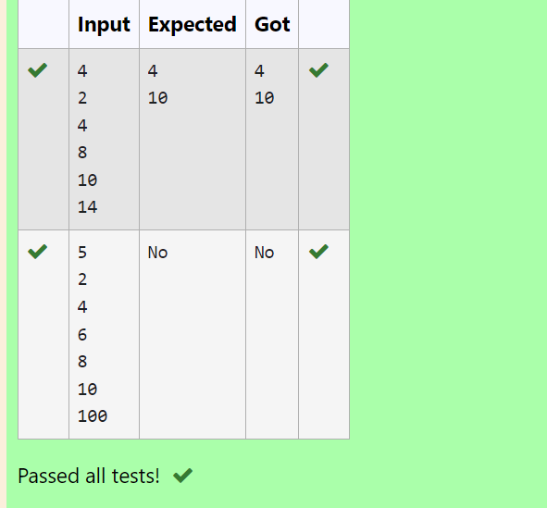

**RESULT:** Thus the program is executed successfully.

**PROGRAM 5:**

**AIM:** Write a Program to Implement the Quick Sort Algorithm

### ALGORITHM:

Step 1: Input the array size and elements. Step 2: Define the swap function.

Step 3: Define the partition function. Step 4: Define the quicksort function.

Step 5: Call the quicksort function in the main() function.

### PROGRAM:

#include<stdio.h>

void quicksort(int arr[],int first,int last){

int i, j, pivot, temp;

if(first<last){

pivot=first;

i=first;

j=last;

while(i<j){

while(arr[i]<=arr[pivot]&&i<last)

i++;

while(arr[j]>arr[pivot])

j--;

if(i<j){

temp=arr[i];

arr[i]=arr[j];

arr[j]=temp;

}

}

temp=arr[pivot];

arr[pivot]=arr[j];

arr[j]=temp;

quicksort(arr,first,j-1);

quicksort(arr,j+1,last);

}

}

int main()

{

int n;

scanf("%d",&n);

int arr[n];

for(int i=0;i<n;i++)

{

scanf("%d",&arr[i]);

}

quicksort(arr,0,n-1);

for(int i=0;i<n;i++)

{

printf("%d ",arr[i]);

}

}

### OUTPUT:

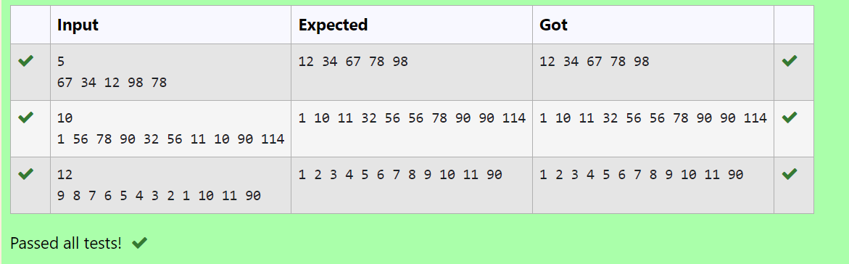

**RESULT:** Thus the program is executed successfully.